I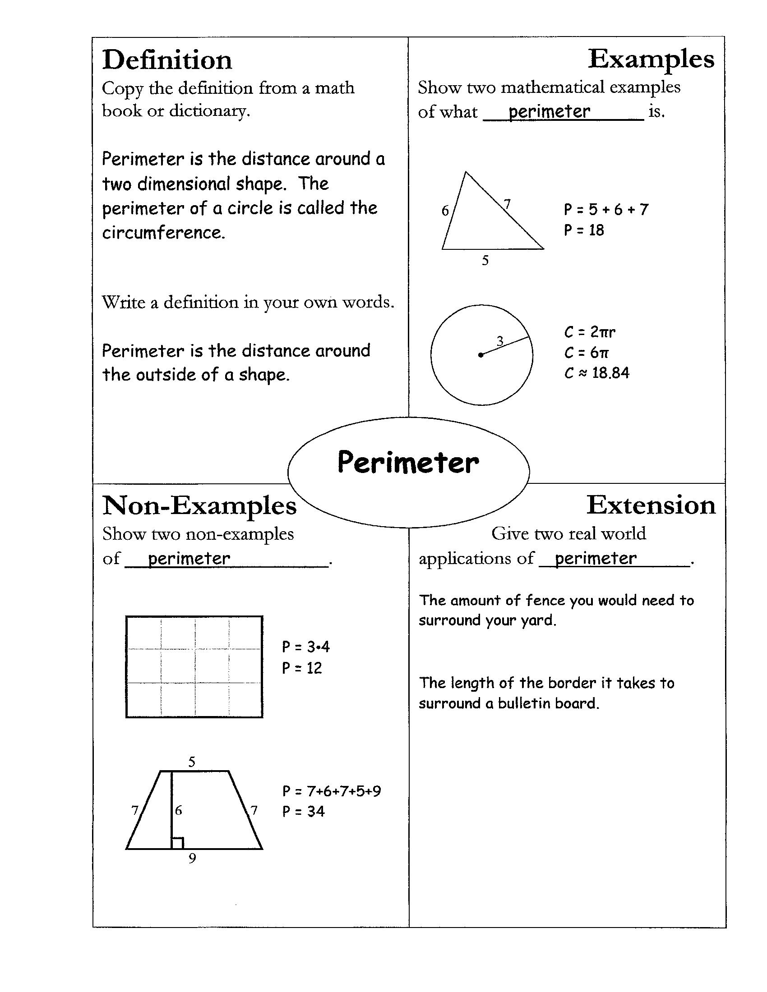
Increasing Accessibility to Algebra and Geometry FRAYER MODEL

