FRAYER MODEL—Strategy for Vocabulary Development
Sample for Data Analysis: Line of Best Fit

TERM | EXAMPLES
Definition:  A line drawn on a scatter plot to estimate the relationship between two sets of data  Give 3 facts about a line of best fit.  1.It is the line that comes the closest to the largest number of dots on the scatterplot of the two sets of data. (It might not actually contain any of the points on the scatterplot.)  2. We can estimate the line of best fit by hand by trying to find the line that hits the most number of points in the scatterplot. We can use the graphing calculator to graph the scatterplot and use the LinReg(ax+b) in the STAT menu to find the line of best fit using a mathematical method built in to the graphing calculator.  3. The relationship between the quantities can be positive or negative or there may be no relationship. | Sketch/give 2 examples that illustrate what a line of best fit is.
NON-EXAMPLES | EXTENSION
Sketch/give 2 non-examples of a line of best fit.  The line of best fit is not  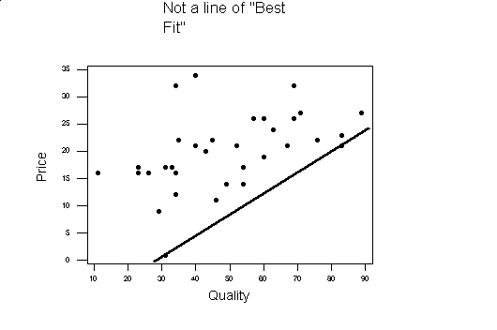  The line goes through 2 of the points of the scatterplot but all the rest of the points are above the line. | Give 2 examples of how a line of best fit might be used in the real world.  - In medicine, doctors can use the line of best fit as a prediction tool for other values of the dependent variable with respect to the x variable (like weight v height).  - In education, teachers might be able to predict how well a student will do on a final exam based on the number of hours the student studied using a line of best fit of previous years’ students results and the number of hours studied.

FRAYER MODEL—Strategy for Vocabulary Development
Sample for: _________________________________

TERM | EXAMPLES
Definition from math book or math dictionary:  Definition in your own words: | Sketch/give 2 examples that illustrate what ____________________ is.
NON-EXAMPLES | EXTENSION
Sketch/give 2 non-examples of _____________________. | Give 2 examples of how__________________ might be used in the real world.

