SORT of GRAPHS Cut out both sets of cards to prepare for the graph sort.
1. | 2.  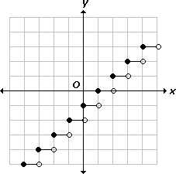 | 3.
4.  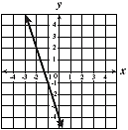 | 5.  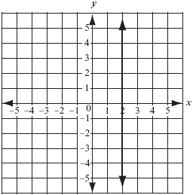 | 6.
7. | 8. | 9.
10. | 11. | 12.
13. | 14. | 15.
16.  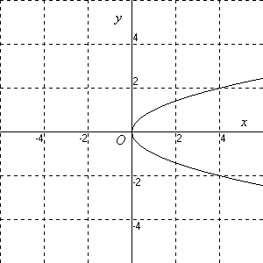 | 17.  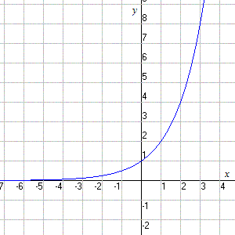 | 18.

SORT of GRAPHS Cut out both sets of cards to prepare for the graph sort.
19. | 20. | 21.
22. | 23.   | 24.
25. | 26. | 27.

28.  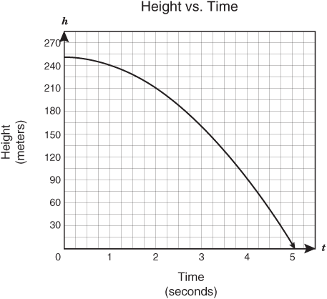 | 29.  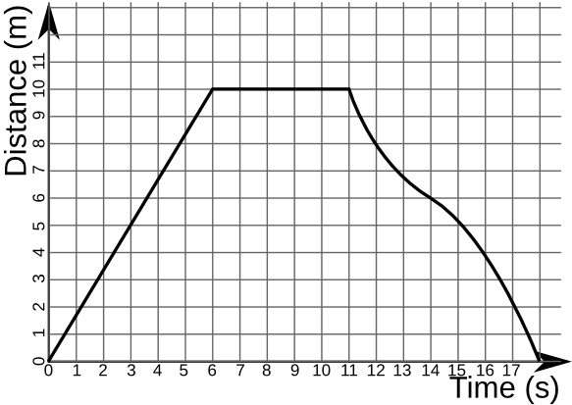 | 30.
31. | 32.  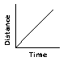 | 33.  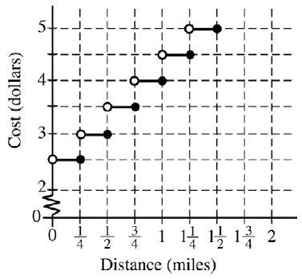
34. 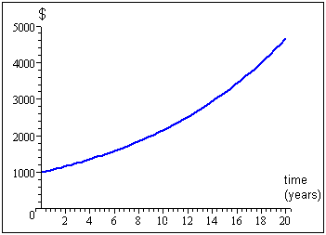 | 35.

