FRACTIONS SORT

A | B | C
D | E | F
G  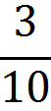 | H | I
J | K | L
M | N | 0

