Verbal | Table
Write a story problem to go along with the table. | 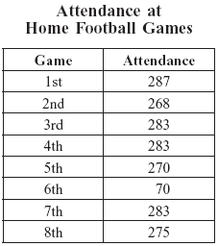
Organized List | Analysis
List the attendance at the 8 home football games in order from least to greatest. | Link 2.7
  What is the range of the attendance for the 8 home football games last season? Show or explain how you got your answer.
  Determine each of the following measures of the attendance for the 8 games.  - mean  - median  - mode  Show how you got your answers! | Determine each of the following measures of the attendance for the 8 games.  - mean  - median  - mode  Show or explain how you got each of your answers
Communicating and Connecting What We Know About
Data Analysis and Central Tendency
Name ___________________________

