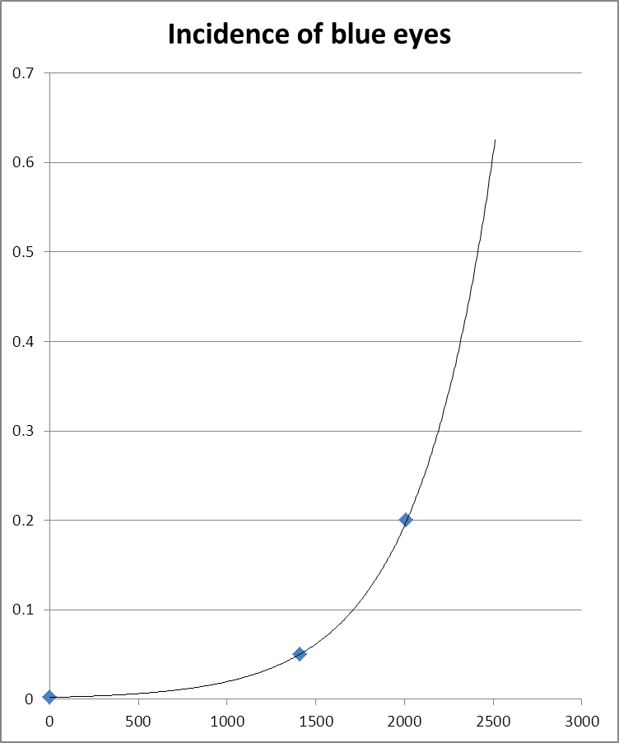
Year | Incidence of blue eyes
1 | 0.002
1411 | 0.05
2011 | 0.2

Blue-eyed humans were once very rare. Virtually all individuals had shades of brown or gray eyes. About 2000 years ago, estimates place the incidence of blue eyes at about 0.2% of the population. The evidence suggests that blue eyes became more common very slowly at first, and began to be much more common about 700 years ago, when blue-eyed individuals accounted for about 5% of the population. Now, the incidence of blue eyes is at about 20% of the world population.
Assuming exponential growth, when could blue eyes be expected to be found in 40% of the population?

This is the answer space.

