Fraction:  Decimal: | Number Line:
Money:  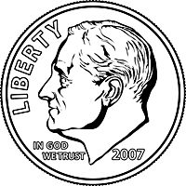 | Hundredths Chart:
Fraction:  Decimal: | Number Line:
Money: | Hundredths Chart:
Fraction:  Decimal: | Number Line:
Money: | Hundredths Chart:

