Communicating and Connecting What We Know About Transformations

Original Image  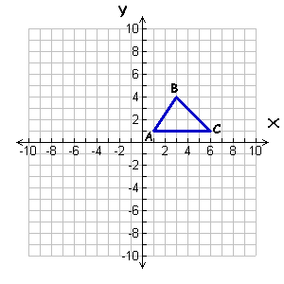 | Reflect in x-axis  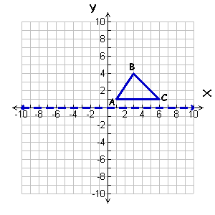
  Original Image | Transformed Image
  A (______, ______) → | A’ (______, ______)
  B (______, ______) → | B’ (______, ______)
  C (______, ______) → | C’ (______, ______)
Reflect in y-axis  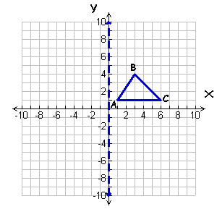 | Reflect in line y = -2  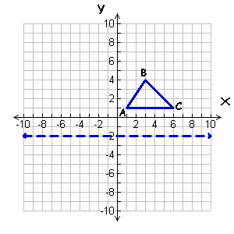
  A (______, ______) → | A’ (______, ______)
  B (______, ______) → | B’ (______, ______)
  C (______, ______) → | C’ (______, ______)
  A (______, ______) → | A’ (______, ______)
  B (______, ______) → | B’ (______, ______)
  C (______, ______) → | C’ (______, ______)
Reflect in line x = -2  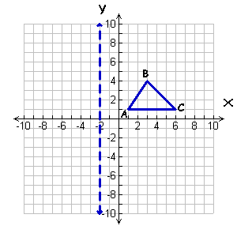 | Reflect in line y = x  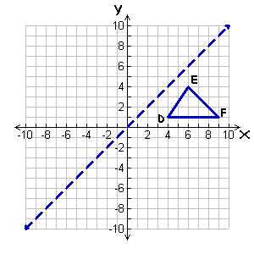
  A (______, ______) → | A’ (______, ______)
  B (______, ______) → | B’ (______, ______)
  C (______, ______) → | C’ (______, ______)
  D (______, ______) → | D’ (______, ______)
  E (______, ______) → | E’ (______, ______)
  F (______, ______) → | F’ (______, ______)
Rotate 90º Counterclockwise | Rotate 180º Counterclockwise
  A (______, ______) → | A’ (______, ______)
  B (______, ______) → | B’ (______, ______)
  C (______, ______) → | C’ (______, ______)
  A (______, ______) → | A’ (______, ______)
  B (______, ______) → | B’ (______, ______)
  C (______, ______) → | C’ (______, ______)

