Polygons - #1

Verbal  The number of diagonals in a convex polygon can be drawn into the polygon.  Draw the diagonals | Table
  number of sides (n) | number of diagonals from each vertex | total number of diagonals (d)
  3 (triangle) | 0 | 0
  4 (quadrilateral) | 1 | 2
  5 (pentagon)
  6 (hexagon)
  7 (heptagon)
  8 (octagon)
  …
  17 (17-gon)
  …
  n (n-gon)
Graph  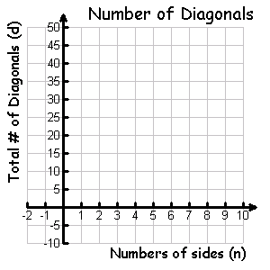 | Algebraic  - How many diagonals are in a 17-gon? How did you get this value?  - How many diagonals are in an n-gon? How did you get this expression?  - If an n-gon has 209 diagonals, determine the number of sides.
Polygons - #2

Verbal  The sum of the angles in a convex polygon can be determined by drawing all possible diagonals from ONE vertex – cutting the polygon into triangles.  Draw the diagonals from the indicated vertex. | Table
  Number of sides (n) | # of Triangles Formed | Sum of angles (S)
  3 (triangle) | 1 | 180°
  4 (quadrilateral) | 2
  5 (pentagon)
  6 (hexagon)
  7 (heptagon)
  8 (octagon)
  …
  17 (17-gon)
  …
  n (n-gon)
Graph  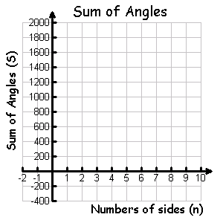 | Algebraic  - What is the sum of the angles in a convex pentadecagon?  - What is the sum of the angles in a convex n-gon?  - If the sum of the angles of an n-gon is 5220 degrees, determine the number of sides.

Polygons - #3

Verbal  Regular Polygons are convex polygons that are equiangular and equilateral. In this link, you will find the measure of ONE interior angle in a regular polygon. | Table
  Number of sides (n) | Measure of one interior angle in a regular polygon (i)
  3 (triangle) | 60°
  4 (quadrilateral)
  5 (pentagon)
  6 (hexagon)
  7 (heptagon)
  8 (octagon)
  …
  17 (17-gon)
  …
  n (n-gon)
Graph  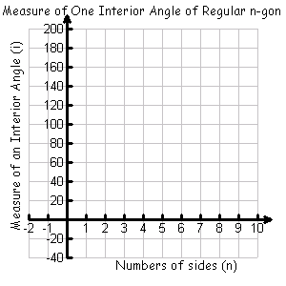 | Algebraic  - What is the measure of one of the angles in a regular 18-gon?  - What is the measure of one of the angles in a regular n-gon?  - If the measure of one of the angles of a regular n-gon is 165 degrees, how many sides does it have?  - As the value of n increases toward infinity, what does the measure of one interior angle of a regular n-gon approach?
Polygons - #4

Verbal  The sum of the exterior angles in a convex polygon. | Table
  Number of sides (n) | Sum of exterior angle (E)
  3 (triangle) | 360°
  4 (quadrilateral)
  5 (pentagon)
  6 (hexagon)
  7 (heptagon)
  8 (octagon)
  …
  17 (17-gon)
  …
  n (n-gon)
Graph  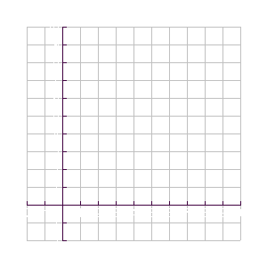 | Algebraic  - What is the sum of the exterior angles in a convex 17-gon?  - What is the sum of the exterior angles in a convex n-gon?

Polygons - #5

Verbal  The measure of ONE exterior angle in a regular polygon. | Table
  Number of sides (n) | Measure of ONE exterior angle in a regular polygon (e) | Measure of ONE interior angle in a regular polygon (i)
  3 (triangle) | 120°
  4 (quadrilateral)
  5 (pentagon)
  6 (hexagon)
  7 (heptagon)
  8 (octagon)
  …
  17 (17-gon)
  …
  n (n-gon)
Graph  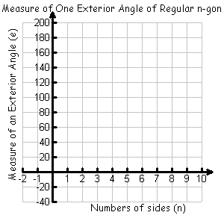 | Algebraic  - What is the measure of one exterior angle in a regular 36-gon?  - What is the measure of one exterior angle in a regular n-gon?  - If the measure of one exterior angle of a regular n-gon is 8 degrees, how many sides does it have?

