Rule of 4 Link Sheet
Communicating what we know about: Patterns
Use pattern tiles as needed to help you complete the Link Sheet.
Models * | Table of Values
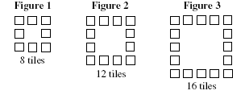  Sketch Figures 4 and 5 below:
  Figure | Number of Tiles
  1
  2
  3
  4
  5
  :
  :
  12
  n
Graph | Equation
 | * Pattern adapted from the 2003 Massachusetts Comprehensive Assessment (MCAS) Grade 6 Test

