Using a picture/sign to make Rule of 4 Connections— Canoe Rentals
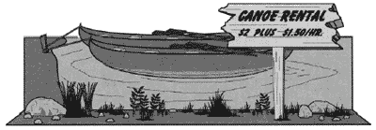
Marion wants to rent a canoe to go out on a lake. The cost is $2.00 plus $1.50 for each hour.

a. Make a table showing how much it would cost to rent a canoe for 1, 2, 3, and 4 hours.
b. Using numbers, symbols, and the variable n, write an expression for how much it would cost to rent the canoe for n hours.
c. Marion has $14.00. What is the greatest number of hours she can rent the canoe? Show your work or explain how you found your answer.

Adapted From: Massachusetts Comprehensive Assessment System, 2001, Grade 6 Test
Rule of 4 Link Sheet—Canoe Rental

Table  Make a table showing how much it would cost to rent a canoe for 1, 2, 3, and 4 hours. | Graph  Make a graph showing the cost to rent a canoe for the times given in the table.
Expression/Equation  Using numbers, symbols, and the variable n, write an expression for how much it would cost to rent the canoe for n hours. | Communicate  Marion has $14.00. What is the greatest number of hours she can rent the canoe? Show/explain how you found your answer below.

