LINK SHEET Making (Phone) Connections
You’ve purchased the $20 phone card, front and back shown.
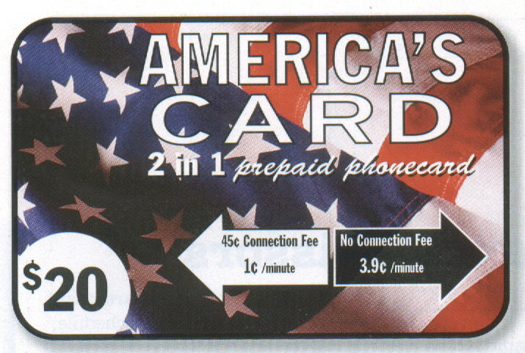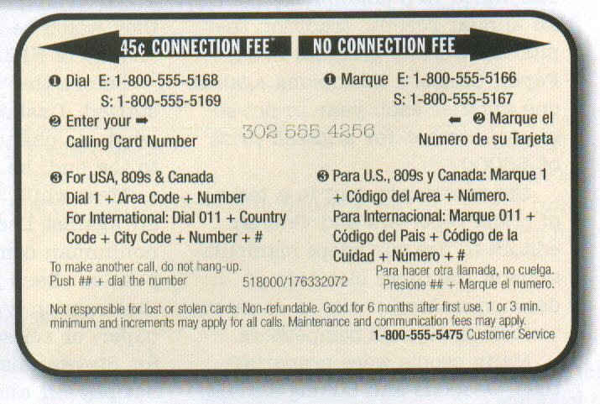

Complete the table to show Graph the two functions, Y₁ and Y₂ below.
the cost of making various
length calls (x) both with a
connection fee (Y₁) and without
a connection fee (Y₂).

x | Y₁ | Y₂
1
2
3
4
5
10
15
20
25
Based on the information, write the equations for:
Y₁ = Y₂ =

Communicate what you know by answering the questions:
- For a 10-minute call, which option costs less? Explain/show how you know.

- When is it to your advantage to choose a connection fee? Explain.

3. With a $20 phone card, what is the maximum number of five-minute calls you
can make? Explain/show how you know.

4. What is the maximum number of sixty-minute calls you can make?
Explain/show how you know.

