Polynomial Functions LINK 1
Verbal | Numerical
If f(x) is a polynomial function with degree n then f(x) has n zeros.  f(x) = x²-4  - degree = _______  - number of zeros = ______
  x | f(x)
Graphical | Algebraic
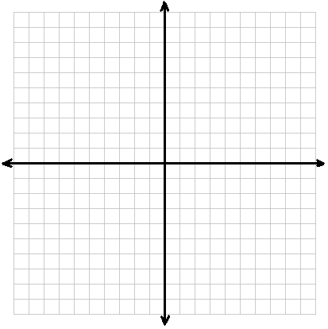
Polynomial Functions LINK 2
Verbal | Numerical
Sometimes zeros occur more than once (called repeated zeros)  f(x) = x²-6x+9  degree = ______  number of zeros = ______
  x | f(x)
Graphical | Algebraic

Polynomial Functions LINK 3
Verbal | Numerical
If a+bi is a zero then a-bi is also a zero  - Only real zeros will show up as x intercepts  f(x) = x⁴ - 1  degree = ______  number of zeros = ______
  x | f(x)
Graphical | Algebraic

Polynomial Functions LINK 4
Verbal | Use the theorem
Rational number – a number than can be written as a quotient of integers  Rational zero test – for a polynomial function f(x) every rational zero has the form where p is a factor of the constant term and q is a factor of the leading coefficient | List the possible rational zeros of  Constant term = _______  Leading coefficient = _______  Possible rational zeros
Test using synthetic division | Algebraic
Test the rational zeros (use graphing calculator to narrow possibilities) using synthetic division. | Write p(x) as a product of factors. Use synthetic division answers to help.  Write p(x) as a product of linear factors

