Inverse LINK
Function and inverse | Table  Function/Inverse
f ⁻¹(x)=?  Use the table and the graph to help you find the equation for f inverse.
  x | f(x) |  | x | f ⁻¹(x)
Graph  Use two different colors | Function and inverse Algebraically
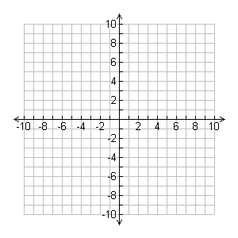

Function Terminology
Consider the function f(x). Define each of the following terms
Independent variable
Dependent variable
Name of the function
Domain
Range
Implied domain

Difference Quotient =
Evaluate the difference quotient for each of the following functions:

Function LINK II
Function | Numerical
  x | Y
Graph | Analysis
- What is the domain of this function?

- What is the range of this function?

- Where is it increasing?

- Where is it decreasing?

- What are the relative local maxima?

- What are the relative or local minima?

- What are the zeros of the function?

