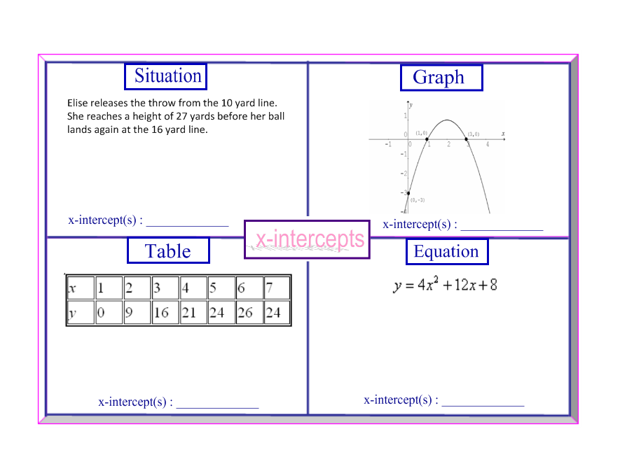
Determine the x-intercepts for each of the four representations. Name: _____________________________

