Verbal Description | Table of Values
Suppose your class is planning a skating party to celebrate the end of the school year. Your committee is in charge of finding a place to rent in-line skates for a reasonable price. You get a quote from Roll On America. Roll On America charges $100 plus $4.00 per person for group rates.

Graph | Symbolic Rule
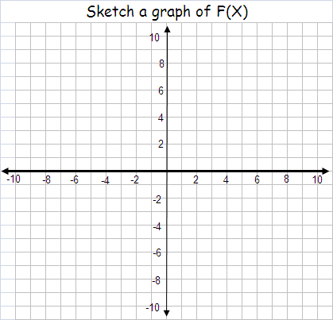 | Write the equation that will tell the cost any size group.

Complete two of the three boxes

Name: _______________________________

Date: ________/_________/____________

