Verbal Description | Table of Values
Rodney is starting a horse-grooming business.  - His initial expense will be a one-time cost of $200 for equipment.  - His earnings will be $40 per horse groomed.  Rodney's profit will be equal to his earnings for all horses groomed minus his initial expense.
  X axis | Y axis
Graph | Symbolic Rule
plot eight points with coordinates (x, y), in which x and y are defined as follows:  - x = the number of horses groomed (in whole numbers from 0 through 7)  - y = Rodney's profit, in dollars, if x horses are groomed  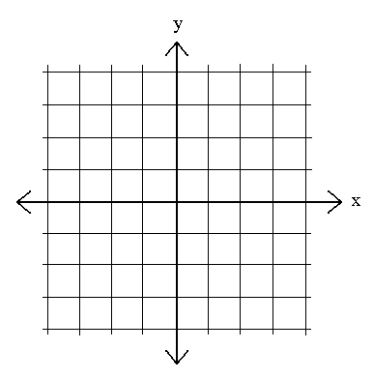 | Write the equation that shows a profit.  What will be Rodney's profit if 15 horses are groomed?

Complete two of the three boxes

Name: _______________________________

Date: ________/_________/____________

