Exploring 3D Geometry with Polydrons!!

Use the required polydron pieces to create six different polyhedra described on each of the task cards.

Assembling the Polydron pieces | Disassembling a Polydron polyhedron
Lay one Polydron flat on the tabletop and push another Polydron at an angle into the correct openings. When properly connected, the pieces will stay hinged together.  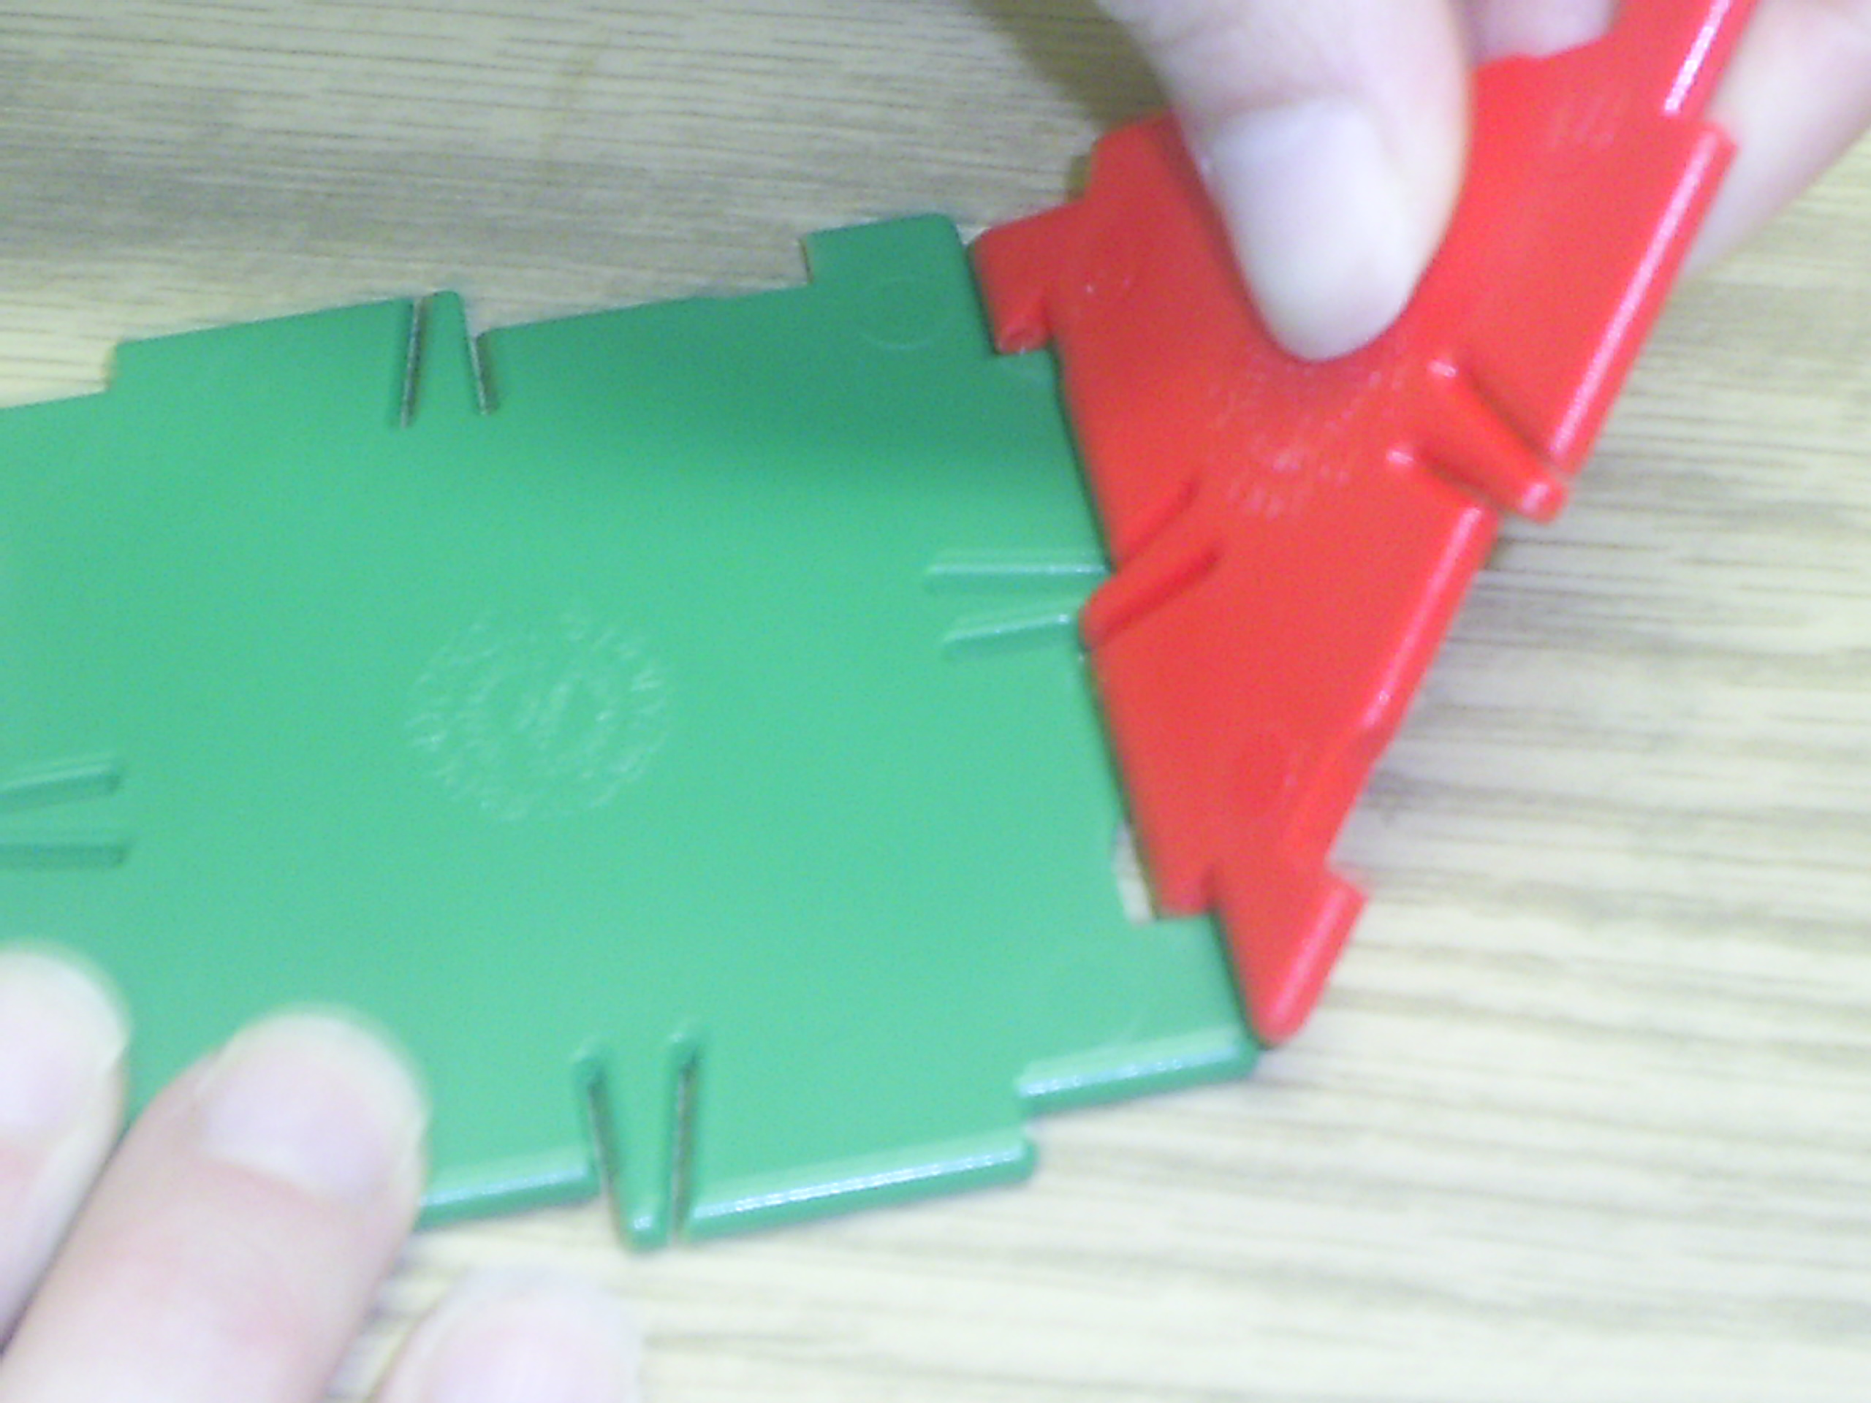 | Use the tip of another Polydron to pry away connected Polydrons at a vertex. If all Polydron pieces are in use, pry the tip of a pen into the vertex and pop the pieces out.  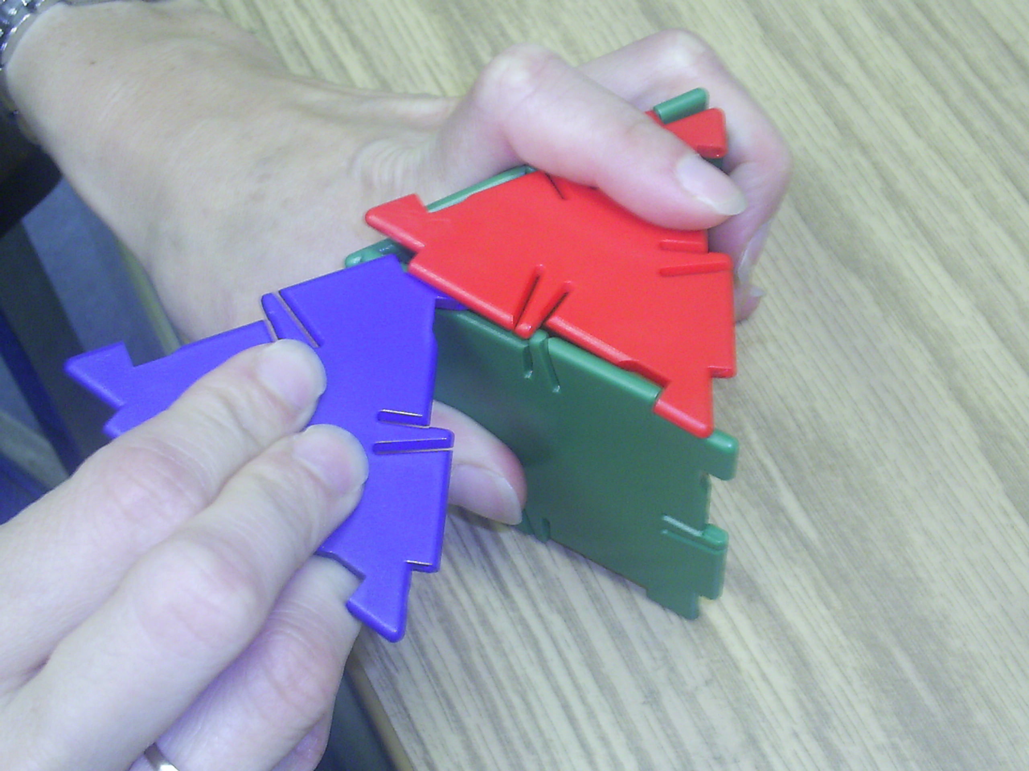

Be sure to name each figure and determine its number of faces, vertices, and edges. Next, draw TWO different nets for each figure. Finally, complete the table below using the information from the six polyhedra you built.

Figure | Name | # of Faces | # of Edges | # of Vertices
A
B
C
D
E
F

Look for a number pattern among the number of faces, edges, and vertices of the polyhedra. Explain the pattern in your own words. _________________________
______________________________________________________________________________________________________________________________

Figure A |  |  | Figure B
6 squares |  |  | 4 equilateral triangles
Name: _________________ |  |  | Name: __________________
#F:___ #E:___ #V:___ |  |  | #F:___ #E:___ #V:___

Figure C |  |  | Figure D
1 square, 4 equilateral triangles |  |  | 3 squares, 2 equilateral triangles
Name: _________________ |  |  | Name: __________________
#F:___ #E:___ #V:___ |  |  | #F:___ #E:___ #V:___

Figure E |  |  | Figure F
8 equilateral triangles |  |  | 2 squares, 8 equilateral triangles
Name: _________________ |  |  | Name: __________________
#F:___ #E:___ #V:___ |  |  | #F:___ #E:___ #V:___

