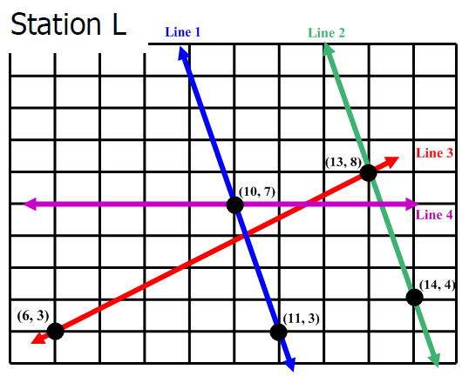
Line | Slope | Y-intercept | Equation y=mx+b
Line 1
Line 2
Line 3
Line 4

