Name(s)_______________________________
F-U-N-C-T-I-O-N LAB
Visit each station, in any order, with your partner(s). You may use a calculator to help you work on each.
Check in with the teacher to correct your work before beginning at another station.
F
U
N
C
T
I
O
N

F | What is the definition of a Function?
U | 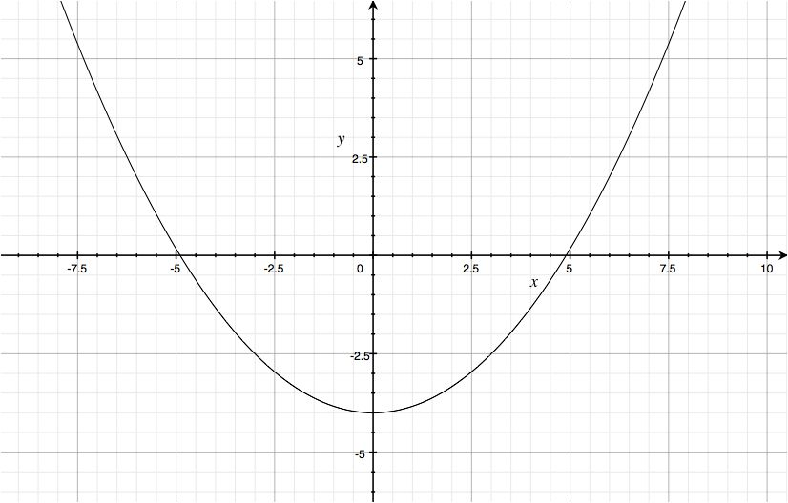  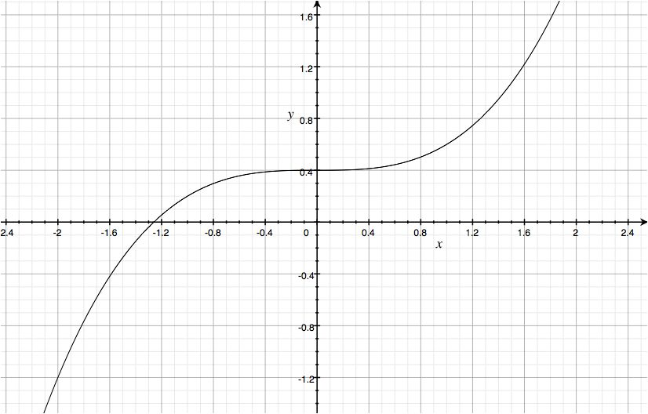  Which of the following Graphs are Functions. Explain How you know  a. b. c. 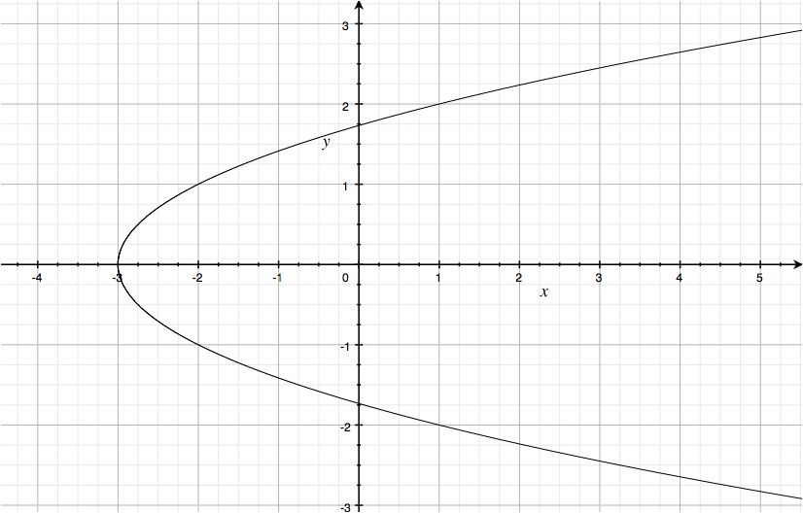
N | Find the following function values for f(x) = 5x - 8  a. f(0) b. f(1) c. f(-7) d. f(100) e. f(t) f. 3f(t)
C | Determine which of the following sets of relations is NOT a function. Explain how you know it’s not. a. { (-2, 4), ( 1, 5), (-4, -6), (8, 2)} b. { (6, 0), (5, -7), (6, -4), (-1, 8) } c. {(1, 2), (-3, 2), (-5, 2), (8, 2)} d d. {(3, 5), (1000, -1), (-1000, 9), (1, 4)}
T | Fill in the links sheet for the function given. Attach the links sheet to your Lab.
I | Draw a quick sketch of  - a relation that is not a function  - a relation that is a function
O | What is the only type of linear graph that is not a function? Draw a quick sketch to show why it’s not a function
N | Determine whether the following equations are functions by using the replacement set x= { -2, -1, 0, 1, 2}  - -3x + y = 8 b. y = 4 c. x² -1 = y

STATION F
What is the definition of a Function?

STATION U
Which of the following Graphs are Functions. Explain How you know
a. b. c.

STATION N
Find the following function values for f(x) = 5x - 8
a. f(0) b. f(1) c. f(-7) d. f(100) e. f(t) f. 3f(t)

STATION C
Determine which of the following sets of relations is NOT a function. Explain how you know it’s not.
a. { (-2, 4), ( 1, 5), (-4, -6), (8, 2)} b. { (6, 0), (5, -7), (6, -4), (-1, 8) } c. {(1, 2), (-3, 2), (-5, 2), (8, 2)} d. {(3, 5), (1000, -1), (-1000, 9), (1, 4)}

STATION T
Fill in the links sheet for the function given. Attach the links sheet to your Lab.

STATION I
Draw a quick sketch of
- a relation that is not a function
a relation that is a function

STATION O

What is the only type of linear graph that is not a function? Draw a quick sketch to show why it’s not a function

STATION N
Determine whether the following equations are functions by using the replacement set x= { -2, -1, 0, 1, 2}
- -3x + y = 8
- y = 4
- x² -1 = y

