Stem and Leaf Plot

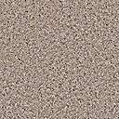

0 4
1 2 4 5 9
 2 6 6 8

3 5 7
The box-and-whisker plot shown below represents the heights, in inches, of the members of the Central High School girls’ basketball team.
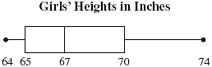
What is the median height of the members of the team?
 | A. | 67 inches
 | B. | 68 inches
 | C. | 69 inches
 | D. | 70 inches

- 3 9

