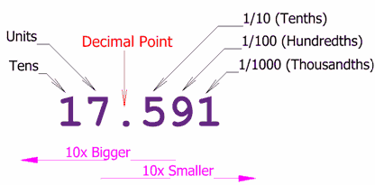
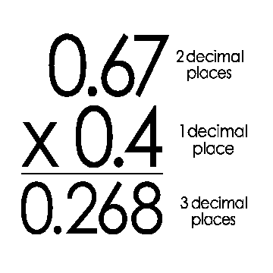

Place Value
Powers of Ten
Round to the Nearest Cent!
Percents

