[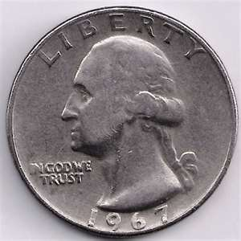](http://images.search.yahoo.com/images/view;_ylt=A0PDoS7jS4pO9XYAXA2JzbkF;_ylu=X3oDMTBlMTQ4cGxyBHNlYwNzcgRzbGsDaW1n?back=http://images.search.yahoo.com/search/images?p=quarter&ei=UTF-8&fr=yfp-t-701&b=1&tab=organic&w=640&h=640&imgurl=0.tqn.com/w/experts/Coin-Collecting-2297/2010/11/DD-quarter.jpg&rurl=http://en.allexperts.com/q/Coin-Collecting-2297/2010/11/1967-quarter-2.htm&size=113.1+KB&name=Coin+Collecting:+1967+quarter,+1967,+quarter&p=quarter&oid=8033947c00c6c14ecfc27f7fb7ddc335&fr2=&fr=yfp-t-701&tt=Coin+Collecting:+1967+quarter,+1967,+quarter&b=0&ni=28&no=10&tab=organic&sigr=12ah6ffc5&sigb=12svbelar&sigi=11vf5uatj&.crumb=ZDDnDEWRr58) [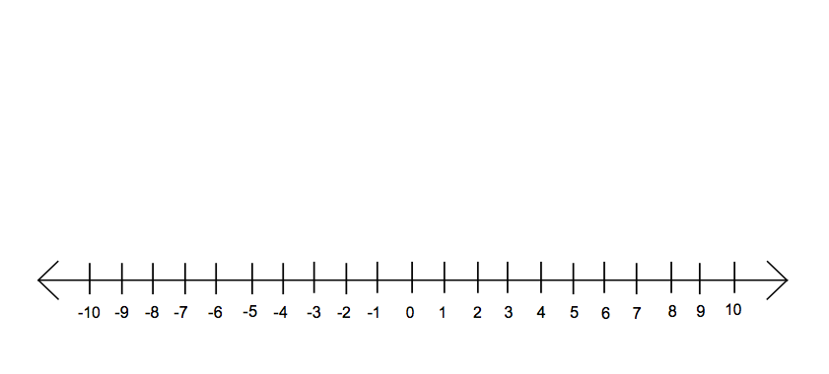](http://rds.yahoo.com/_ylt=A0PDoX5wT4pOrwIAn5OjzbkF;_ylu=X3oDMTBpcGszamw0BHNlYwNmcC1pbWcEc2xrA2ltZw--/SIG=11jo40eco/EXP=1317715952/**http:/www.mathematic.ws/?p=6)

**Whole**

**Numbers**

**F**

**R**

**A**

**C**

**T**

**I**

**O**

**N**

**Number Sense Splash**

**Decimals**

$$x^{Ponents}$$

**PEMDAS**

$$\frac{7}{4}$$

**−4**

**value**

**Absolute**