Brainstorm, Organize, Show What You Know
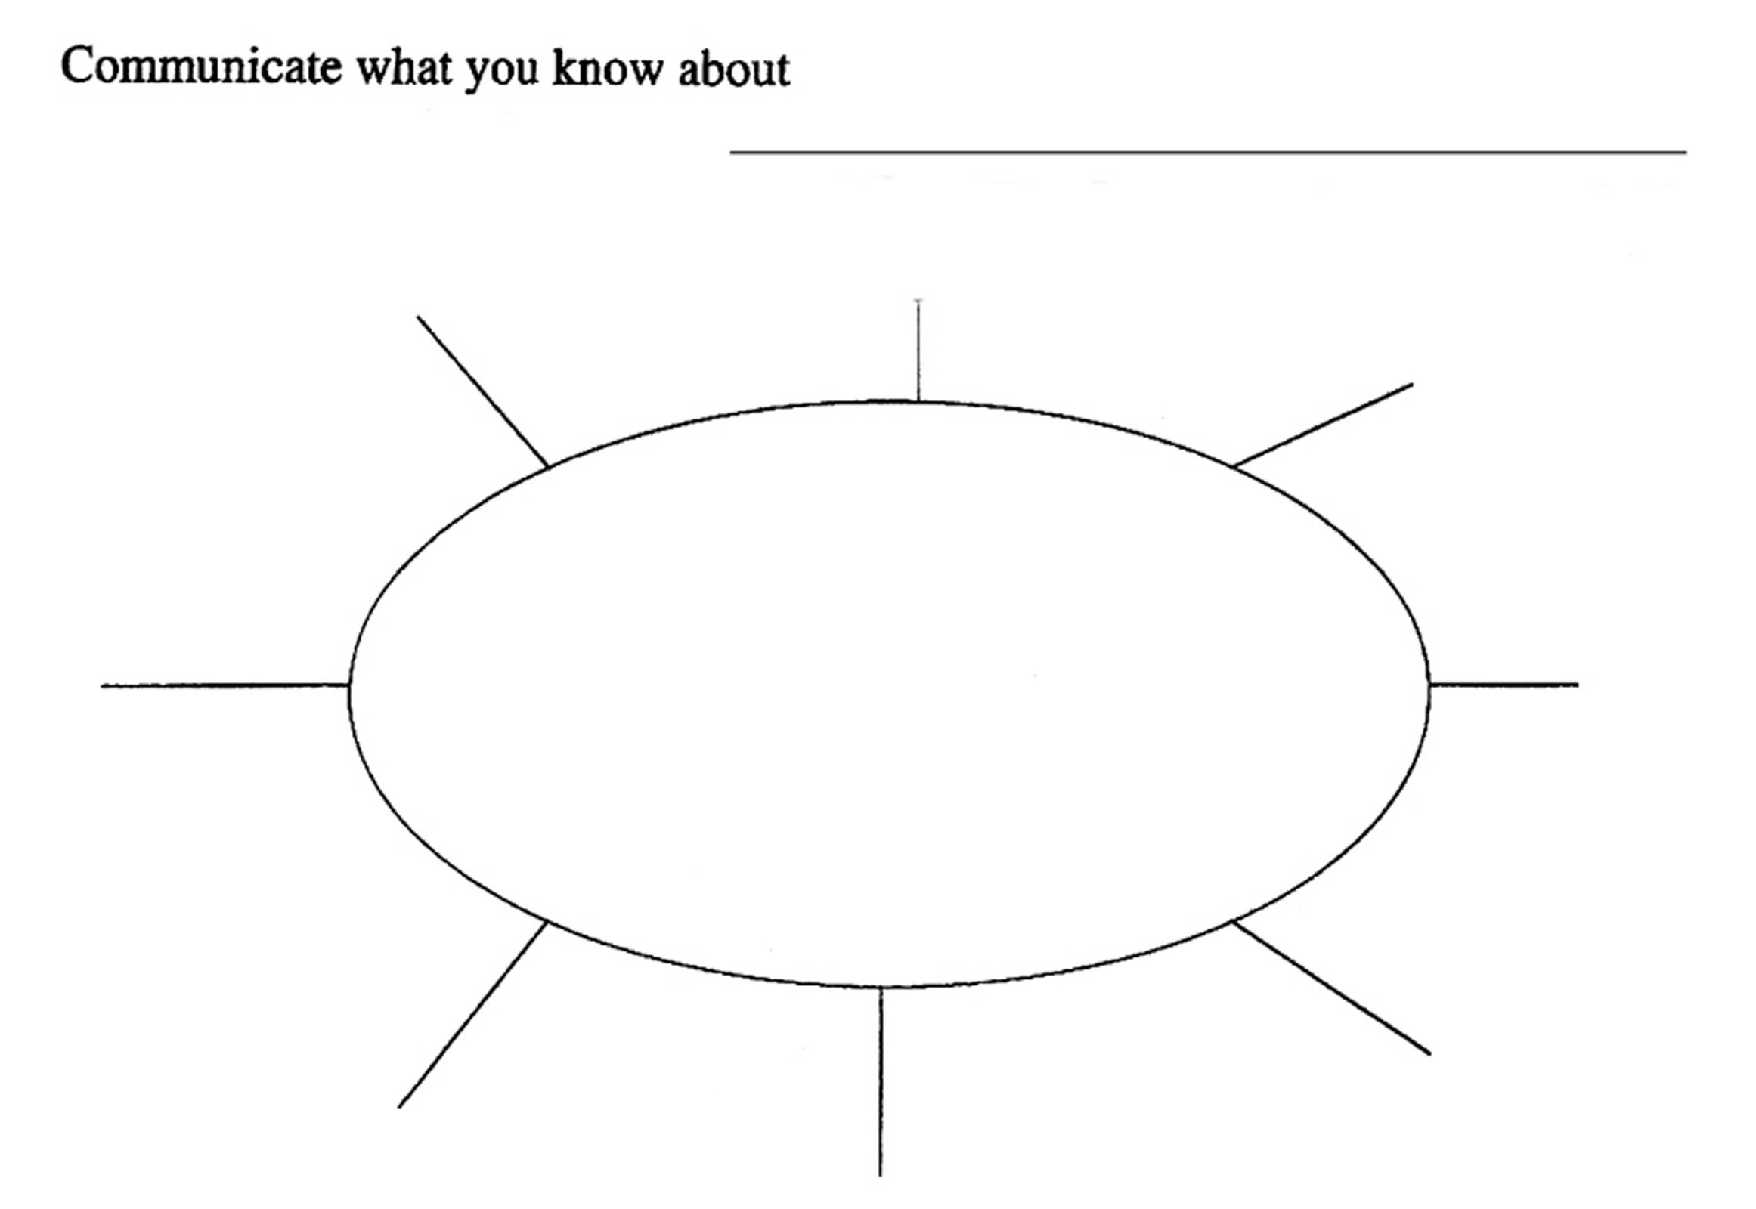
WEB

This graphic organizer is used across all content areas and grades. Students are usually familiar with it as a tool for pre-writing to organize their thoughts. In other content areas, a vocabulary word or character name might be written in the oval of the web.

In our math classes, we use it to activate prior learning, organize newly presented material, and review. In math, we might also use a vocabulary word, but we also use other representations: tables, graphs, equations and diagrams/figures. There are many ways to use the web in math class. The general directions for use are below.

MODELING HOW TO COMPLETE A WEB
As with the other organizers, we always model how to use them in the whole group. For example, in a web drawn on the board or on a transparency on the overhead, the teacher might write an equation, such as y = 3x + 2. The teacher then models how to complete the web by filling in one leg with a mathematical fact such as: “slope of line is 3”. Then the teacher can ask for a student to add another fact. Students volunteer math facts which the students or the teacher records on the other legs of the web. The teacher might need to remind students that we can use multiple representations to help us complete a web. The teacher has to explain about looking for and correcting misconceptions that might be added to a web.

WHEN TO USE A WEB
- Use before beginning to teach a new topic or unit to check for students’ prior knowledge. This helps teachers plan lessons as well as helps students activate their learning from another grade or course.
- Use as a quick warm-up at the beginning of class to help students review individually, in pairs, or in small groups.
- Use to organize notes on related topics.
- Use as a carousel activity with webs on a common topic posted around the room as a review before a classroom test or quiz.
- Use at the beginning of a test or quiz so that students can show what they know about an idea or topic. This also helps them to organize and collect their thoughts as they begin the assessment.

SEE OTHER SIDE FOR ADDITIONAL WAYS TO USE WEBS IN MATH CLASS. → → →

Using Webs in Math Class

We learned about using webs in math class based on how our colleagues teaching other content areas were using them. We initially used webs traditionally…to pre-assess at the beginning of a unit and to review at the end. Over the past 5+ years, we’ve developed additional ways to use webs to support students in learning math, as briefly explained below. Samples of these different types of webs are available on the UMASS Medical School Regional Science Resource Center web site.

- TRADITIONAL USE
Pre-assess…what do you know about the topic in the center of the web?
Review…what do you know now that we’ve studied the topic/concept?

- TAKING NOTES
For the topic in the center of the web, provide the requested information on each leg. (Ex: We do y = sin (x) together, by giving domain, range, symmetry info, period, max and min values, table of values, graph… Then students do y = cos (x) by giving the same info for it on another web)

- WRITING EQUIVALENT FORMS
Given a statement in the center of the web, write an equivalent representation on each leg. (Ex: put 80/100 in the center and ask students to write/represent it 8 additional ways)

- REVERSE WEBS
In a reverse web, info is given on some of the legs of the web and students need to determine what belongs in the center of the web. They then provide additional facts on the remaining legs.

- FOUR OPERATIONS WEB
In this special web, there are only 4 legs. Label one addition (or sum), one subtraction (or difference), one multiplication (or product) and the last one division (or quotient). Then, put a number or expression in the center of the web and have students create number expressions for each operation leg to equal the number in the center—try whole numbers, proper/improper fractions, negative numbers, radical expressions, algebraic fractions…)

