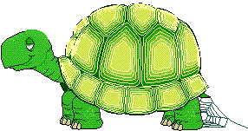
STATION E₂

BORG, THE ENGINEERED TURTLE

Borg the turtle was walking across the road (to get to the other side) , and a very weird person saw him. Borg tried to get away, but alas, he was not so fast. The person subjected Borg to genetic engineering to grow fur on his shell. Assume Borg is semi-spherical, and the hair grows equally and only on the curved surface. Include hair in the radius and round answers to three decimal places.

1. When the rate of change of the volume is 12 cubic feet per second, and Borg has a radius of 14 ft (he's one huge turtle), what is the rate of change of the radius?

2. The weird person wanted Borg to be huggable-soft. This occurs when the rate of change of the volume is 1600 cubic feet/second, and the rate of change of the radius is 13 feet/second. When did Borg reach huggable-soft status(give the radius)?

Epilogue: Borg escaped from the weird person and currently lives with a loving rabbit named Thursday.

Author: Brian Lavoie submitted to Alvirne High School

