STATION T

STATION T

TRIX ARE FOR KIDS

At last, after years of hearing those greedy kids say "Silly Rabbit, Trix are for kids", the Trix Rabbit has finally been able to get his hands on a bowl of that colorful, crispy cereal that we all know as Trix.
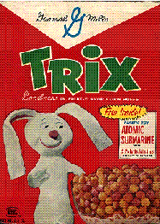
He doesn't have much time because those nosey kids are almost certain to find him before he finishes that tasty bowl of fruity cereal, which, by the way, is a part of his complete breakfast. His cereal bowl is a hemi-sphere, decorated with cute little rabbits.

- At what rate does the rabbit eat his Trix cereal if r = 2.5 inches, and dr/dt = .25 inches/min.

- What do you think the Trix Rabbit might say when the kids find him finishing his bowl of cereal?

Problem submitted by Mrs. Latiuk's Calculus Class, Edison Tech, Rochester, NY to Alvirne H.S.

