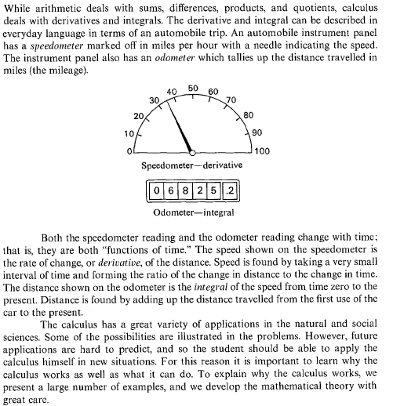
Which is which?
Point of Inflection
AP Calculus
Review
Splash
Intermediate Value Theorem

dy/dx =

and passes through
the point (1,3)

