Verbal | Graph
The graph at the right describes the rate at which the quantity of water in a tank is changing. At t = 0, there are exactly 100 gallons of water in the tank. | 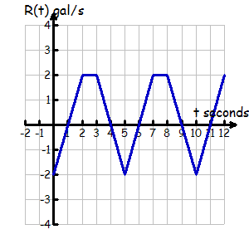
Table | Analysis
 | - State the domain and range of G(t).  - Determine when the rate of flow of water is positive.  - Determine when the rate of flow of water is negative.  - Will the amount of water in the tank ever return to 100 gallons? If so, for what values of t?  - Will the number of gallons in the tank ever level off? Explain your reasoning.  - At what points, if any, are the tangents to G(t) horizontal?  - Write the equation of the tangent line to the function G(t) at t = 5.
  t | G(t)
  0
  1
  2
  3
  4
  5
  6
  7
  8
  9
  10
Communicating and Connecting What We Know About Integrating a Rate

