AP Calc AB Name: ____________________________
Differential Equations LINK
Verbal | Solve Differential Equation
At the beginning of 2010, a landfill contained 1400 tons of solid waste. The increasing function W models the total amount of solid waste stored at the landfill. Planners estimate that W will satisfy the differential equation  dW/dt = (1/25)(W – 300)  for the next 20 years. W is measured in tons, and t is measured in years from the start of 2010. | Find the particular solution W= W(t) to the given differential equation dW/dt with initial condition W(0) = 1400.
Analysis | Slope Field
- 1. Use the line tangent to the graph of W at t = 0 to estimate the amount of waste the landfill contains at the end of first three months of 2010 ($t=\frac{1}{4}$).  - Find $\frac{d^{2}W}{{\text{dt}}^{2}}$ in terms of W. Use $\frac{d^{2}W}{{\text{dt}}^{2}}$ to determine whether your answer to Question 1 is an underestimate or overestimate of the amount of solid waste that the landfill contains at $t=\frac{1}{4}$. | This is the graph of the slope field for the differential equation dW/dt.  Sketch your particular solution for the given initial condition on this slope field.  W(t)  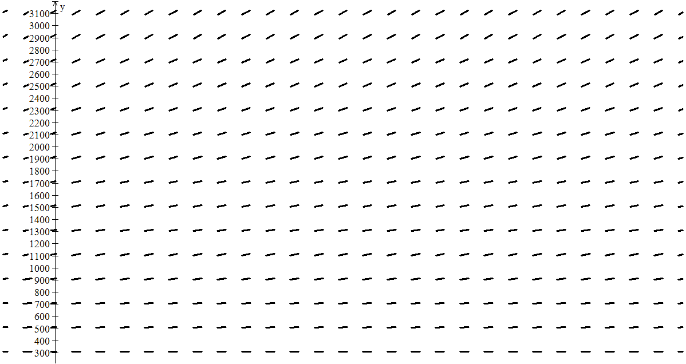  0 2.5 5 7.5 10 12.5 15 17.5 20 T  Adapted from 2011 AB/BC # 5

