Verbal | Table
The functions f and g are differentiable for all real numbers. The function g is strictly increasing.  Additionally, the function h is given by  h(x) = f(g(x)) – 6. | The table below gives values of the functions for selected values of x. Complete the table for the indicated x values for h(x) and h’(x).
  x | f(x) | f’(x) | g(x) | g’(x) | h(x) | h’(x)
  1 | 6 | 4 | 2 | 5
  2 | 9 | 2 | 3 | 1
  3 | 10 | -4 | 4 | 2
  4 | -1 | 3 | 6 | 7
  5 | 2 | -2 | 9 | 10 | ----- | -----
  6 | 7 | 1 | 14 | 3 | ----- | -----
Graph | Analysis
Sketch a graph of h(x) below.  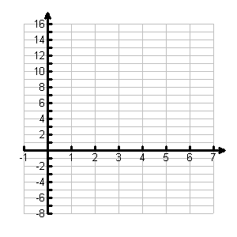 | - Explain why there must be a value r in (1, 4) such that f(r) = 1.  - What is the least number of zeros that the function h(x) could have in the interval (1, 4)? Explain your reasoning.  - Explain why there must be a value b for 1 < b < 3 such that h(b) = -5.  - Write an equation of the tangent line to the graph of h(x) at x = 2.  - If g⁻¹ is the inverse of the function g, write an equation for the line tangent to the graph of y = g⁻¹(x) at x = 2.  Adapted from 2007 AB Question 3
Communicating and Connecting What We Know About Functions

