Verbal | Graph
Given the differentiable functions h(x) and h’(x) as described by a few selected points in the table below: | 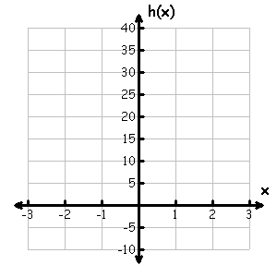
Table | Analysis
 | - Determine the average rate of change (ARoC) of h(x) over the interval [-2, 2].  - Determine the average rate of change of h’(x) over the interval [0, 2].  - Determine the slope of h(x) at x = 2.  - Determine the equation of the tangent line of h(x) at x = 2.  - Draw the tangent line of h(x) @ x = 2 on the graph above.  - Show that there exists a c in [-2, 0] such that h(c) = 10.  - Show that there exists a value r in [-2, 2] such that h’(r) = -12.
  x | h(x) | h’(x)
  -2 | 40 | -84
  -1 | -5 | -16
  0 | -8 | 4
  1 | -5 | 0
  2 | -8 | -4
  3 | -5 | 16
Communicating and Connecting What We Know About ARoC and IRoC

