Verbal | Graph
Given the function:  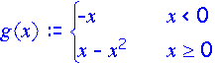 | 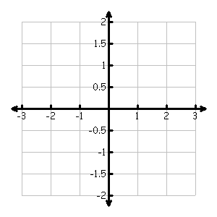
Table | Analysis
 | - Determine the slope of g(x) @ x = -1, @ x= -.5, @ x= -.1,@ x= -.01, @ x = -.001.  - Determine g’(0⁻) and g’(0⁺).  - Determine the average rate of change in the interval [0, 2].  - Determine the slope of g(x) at x = 2.  - Determine the equation of the tangent line of g(x) at x = 2.  - At what points, if any, are the tangents to the graph of g(x) horizontal?
  x | g(x) | g’(x)
  -3
  -2
  -1
  0
  1
  2
  3
Communicating and Connecting What We Know About ARoC and IRoC

