Symbolic & Verbal | Graph
A fruit fly population is given by the function  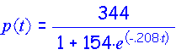  where t represents the time in days and p(t) represents the number of fruit flies. | 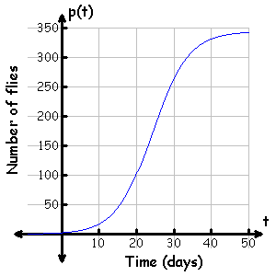
Table | Analysis
- Determine the average rate of change of p(t) over the interval [20, 50]. Please include units.

- Determine the instantaneous rate of change of p(t) at t = 30. Please include units.

- At approximately what time is the population of fruit flies growing most rapidly?

- Determine

Communicating and Connecting What We Know About Rates of Change:
Average and Instantaneous

