Verbal | Graph
Given the function:  f(x) = x³ + 2x - 1  f’(x) = | 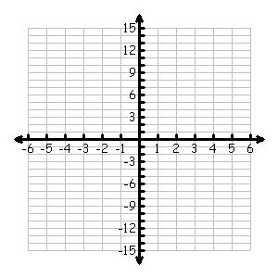
Table | Analysis
 | - Graph f(x) on the axes above.  - Determine the slope of f(x) at x = 1.  - Determine the equation of the tangent line of f(x) at x = 1. Draw this line on the graph above.  - At what points, if any, are the tangents to the graph of f(x) horizontal?  - Let g(x) be the inverse of the function f(x). Since this is true, it is known that f(g(x))=x. Take the derivative with respect to x of both sides of this equation and solve for g’(x).  - Find g’(2).
  x | f(x) | f’(x)
  -2
  -1
  0
  1
  2
Communicating and Connecting What We Know About the Derivative of the Inverse of a Function

