Verbal | Graph
Given the continuous and differentiable function f(x) as described in the table below: | 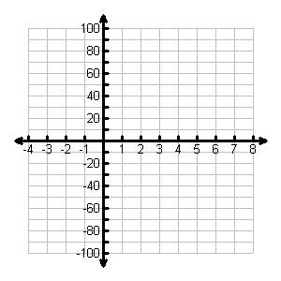
Table | Analysis
 | - Determine the average rate of change (ARoC) of f(x) over the interval [-1, 1].  - Sketch a graph of f(x) and f’(x) on the axes above.  - Determine the equation of the tangent line of f(x) at x = -2.  - Determine the equation of the normal line of f(x) @ x = -2.  - At what points, if any, are the tangents to the graph of f(x) horizontal?  - During what intervals on the domain [-3, 8] is the function f(x) increasing? Decreasing?
  x | f(x) | f’(x)
  -3 | -240 | ---
  -2 | -84
  -1 | 0
  0 | 30
  1 | 24
  2 | 0
  3 | -24
  4 | -30
  5 | 0
  6 | 84
  7 | 240
  8 | 486 | ---
Communicating and Connecting What We Know About the Derivative of a Function

