Symbolic | Graph
Given the relation:  xy + x – 2y – 1 = 0  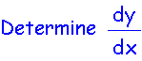 | 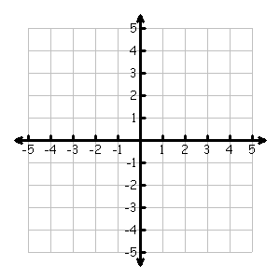
Table | Analysis
 | - Determine the average rate of change of the function over the interval [1, 4].  - Graph dy/dx on the axes above.  - Determine the equation of the tangent line to the curve xy + x –2y – 1 at x = -1.  - At what points, if any, are the tangents to the curve horizontal?  - Determine the point(s) on the curve where the slope is .25.
  x | y | dy/dx
  -3
  -2
  -1
  0
  1
  2
  3
  4
Communicating and Connecting What We Know About the Derivative of a Function

