Symbolic | Graph
Given the function:  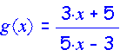  Determine  g’(x) = | 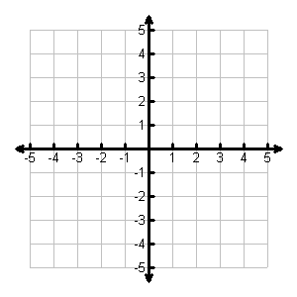
Table | Analysis
- Determine the domain and range of the function g(x).

- Determine the zeros of g(x).

- Where is the function g(x) differentiable?

- Determine

- Graph g’(x) on the axes above.
- Determine the equation of the tangent line of g(x) at the point where the slope is -34.

- When is g’(x) = 0? When is g’(x) > 0? When is g’(x) < 0?

- At what point(s), if any, are the tangents to the graph of g(x) horizontal?

Connecting and Communicating What We Know About the Derivative of a Function

