Verbal | Graph
Given the function:  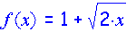  Use the definition of derivative to determine f’(x).  f’(x) = | 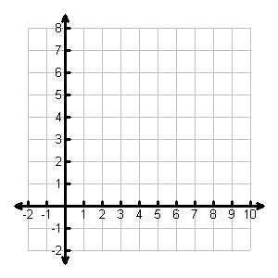
Table | Analysis
- Determine the average rate of change (ARoC) of f(x) over the interval [1, 7].

- Graph f’(x) on the axes above.
- Determine the slope of f(x) at x = 3.

- Determine the equation of the tangent line of f(x) at x = 3.

- Determine the equation of the normal line of f(x) @ x = 3.

- What does the derivative of f(x) tell you about this function?

Communicating and Connecting What We Know About the Derivative of a Function

