Solving Differential Equations and Sketching Slope Fields/Direction Fields

Differential Equation | Solve the Separable Differential Equation
$$\frac{dy}{dx}= \frac{x^{2}}{y^{2}}$$

Table | Graph
Complete the table of values for -3< x < 3 and -3 < y < 3  x y dy/dx | Graph the Slope Field/Direction Field for the values in the table.  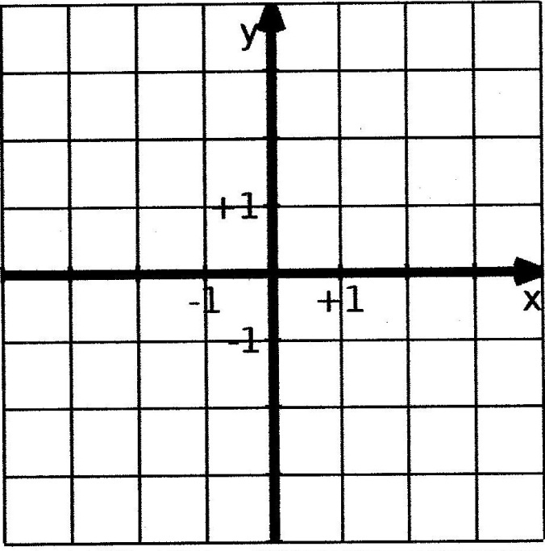  Use your graphing calculator to graph the slope field and the specific equation that satisfies the initial condition that when x = 0, y = 2.  Sketch the equation above.  NOTE: The solution to a differential equation must be a continuous function.

