Exponents
Use the product of powers property to simplify the expression.

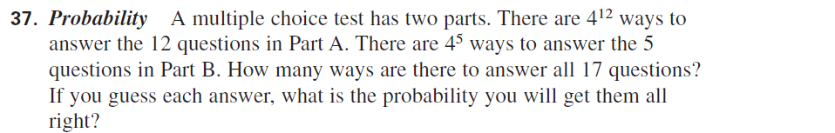

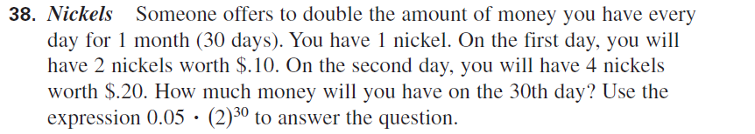

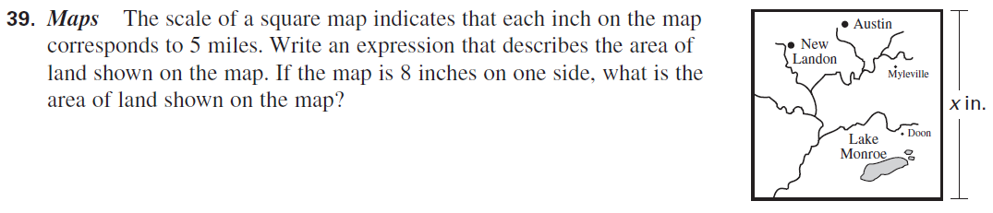
Evaluate the exponential expression. Write your answer as a fraction in simplest form.

Rewrite the expression with positive exponents.

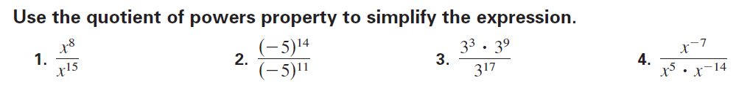

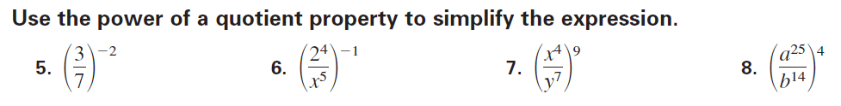

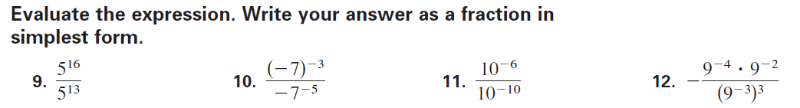

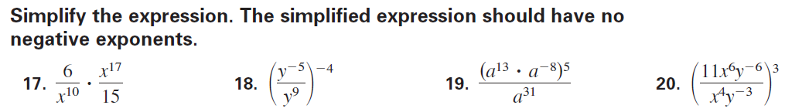

Scientific Notation

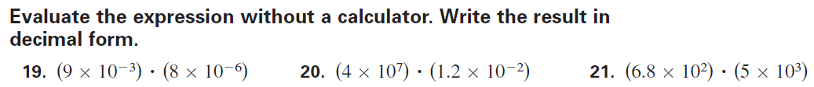

Evaluate the expression without a calculator. Write the result in decimal form.

