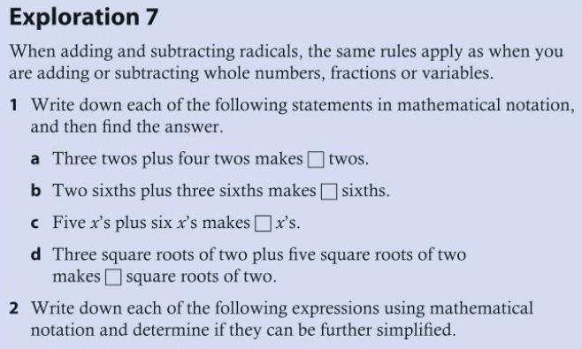
- Three twos plus four fives
- One third plus three quarters
- Six x's plus five y's
- Two square roots of two plus two square roots of three

