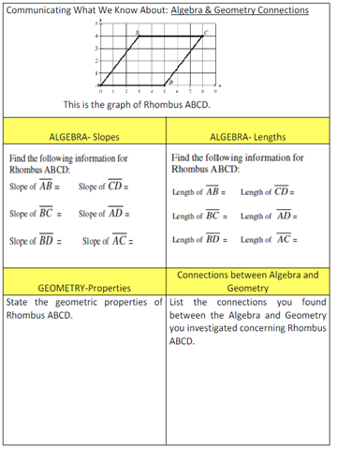
Adapted from 2001 Grade 10 Massachusetts Assessment Test

